**Study on Viral Aerosol Transmission and Detection**

**Abstract:-**

In this research, we suggest using the mechanism of disease dissemination in the atmosphere as an engineering problem. Among the viral modes, aerosol transmission is the most important modes of transmission that don't involve physical contact, when long-distance virus-laden droplets are carried by airflows. In this paper, we examine how these droplets are transported as an uncontrollable molecular communication issue over the source of transmission, while a strong receiver can be created with the use of biosensors. In light of this, we provide a comprehensive construct a system model and obtain a comprehensive mathematical model for the channel of transmission under specific limitations and boundaries circumstances. The system response is derived for both continuous sources like respiration and jet or spontaneous sources like sneezing and coughing. We assumed a receiver design made up of a silicon nanowire field-effect transistor and an air sampler in addition to the transmitter and channel. Next, we create a detection problem to optimize the decision rule for likelihood and reduce the likelihood of the corresponding missed detection. Lastly, we provide a number of numerical findings to show the effects of factors that impact performance and simply justify the feasibility of the proposed setup in related applications.

**Index Terms**— Communication through breath, aerosol transmission, virus detection, molecular communication, nanonetworks, channel modeling, molecular receiver, advection diffusion channel.

1. **INTRODUCTION:**

An growing field of study that focuses on the communication processes involving biological entities is called molecular communication (MC). MC employs molecules as signaling sources, as opposed to traditional wireless communication, which encodes and transmits electromagnetic signals to exchange information. Only recently has this phenomena drawn attention from the scientific world, despite the fact that it is a communication mechanism that most living things inherently possess. Recent developments in nanotechnology and the introduction of nanoscale biosensors or nano technologies are credited with generating this interest and advancing the field's research[1]. The small size, limited energy supplies, memory, and processing capability of the current nanotechnology limit their possibilities. Many nanotechnology must thus interact in order to carry out complex functions, and this is where the idea of MC is crucial. Although current electromagnetic and optical technologies are unable to create links between nanotechnology, MC offers this connection, enabling the formation of a cooperative network of nanotechnology[2]. The construction of artificial networks that can mimic biological networks both within and outside the human body is made possible by research in this field. This will not only aid in comprehending how intricate biological systems like the brain function, but it will also aid in the treatment of a number of illnesses and conditions brought on by malfunctioning internal communication channels [3]. Therefore, it is anticipated that these developments will be crucial for manufacturing, biomedical, and ecological uses [1]. Neural network modeling, the creation of ICT-inspired therapies [3], and intelligent medication delivery are a few newly investigated biomedical applications[4]. In addition to biological applications, MC has been examined from a communications perspective, which emphasizes coding principle, assessment of modulation programs, and the design of effective receivers [5]. It should be mentioned that because of the complexity of the process, the current solutions for traditional communication cannot be easily transferred to MC setups. The problems with MC include non-stationary signal-dependent noise, range restrictions that let nanotechnology communicate over short distances (less than a few micrometers), significant propagation delays, problems with molecule reactivity that lead to high loss rates, memory limitations, power constraints, and connection between bio-nanotechnology and nanotechnology [1]. These difficulties greatly influence the present and future paths of this field's research. Additionally, the ability of these nanoscale sensing structures to interact with living things like bacteria has created a number of new study opportunities. For example, bacterial compounds operate as messengers for communication between bacterial colonies, where receptor bacteria emit light in response to molecules they receive, rather than artificially generated molecules and chemicals[6].

In addition to micro and macro-level applications, researchers have also put efforts in understanding and replicating the existing biological processes/systems and interfacing with them. In this work, we propose a new dimension in MC that focuses on the spread of infections and diseases via aerosols. Viral aerosols are virus-laden droplets that are suspended in air for prolonged periods of time [7]. These particles are dispersed in the surrounding because of molecular diffusion and are carried away by wind and this transport is called aerosol transmission. This transmission of viruses leads to disease spread on a very large scale with a massive impact on human population. It has been shown that aerosol transmission is an important mode of transmission for several viruses such as influeza A virus [8], severe acute respiratory syndrome (SARS) virus [9], lyssavirus [10], rabies [11] and many other pandemics. Unlike the traditional research in MC, for this particular context the message-bearing entities can not be modulated and the message can not be embedded as desired. However, we believe that the virus-laden exhaled air from an infected person can serve as a source of useful information and we need to design our receiver in order to retrieve this information. The significance of this proposed research dimension is even more highlighted in high human population scenarios. It is common to observe Mass gatherings when people get together for sports, recreational, social or religious activities. During these gatherings, the large movement of people from different regions poses high risk of disease transmission and transport of emerging and reemerging diseases to the gathering place. The increase in likelihood of disease transmission during Mass gatherings is reported in [12]–[15]. The detection system proposed in this work can help deal with this problem. If an efficient detection setup is deployed at the entry point of gathering events like railways stations and airports and the likely hosts of diseases and endemics are spotted and treated before they become part of the gathering, the spread of diseases can be significantly prevented. Moreover, if accurate models for virus transport and its dynamics can be established, a blind localization problem can be formulated that can prove helpful in identification of disease sources. Thus, in order to be able take any preventive measures against disease spread, it is essential to characterize and analyze the dynamics of virus transport as has been done in this work.

**II SYSTEM OVERVIEW**

The fundamental design of a single source viral aerosol transmission system is briefly explained in this section. There are three main parts to the suggested system. The first is the diseased person who spreads the infection; throughout the rest of the paper, this person is called the transmitter. The second element is the pathway via which the virus spreads through aerosols. It is possible to expose the gearbox to airflow, or artificial wind. The third element is the receiver side, which seeks to obtain data regarding the disease and/or virus.

The goal of this paper is to recover viral information from aerosols expelled from infected persons' respiratory tracts, as shown in Figure 1. In order to propel the particles towards the detector, the experiment is conducted indoors where artificial airflow with a predetermined velocity can be applied. It should be mentioned that the experimental setup being considered is extremely similar to a real-world scenario in which virus droplets spread due to wind. Therefore, the models developed in this work can be used for both qualitative and quantitative investigation of infection transmission in addition to bio-monitoring applications.

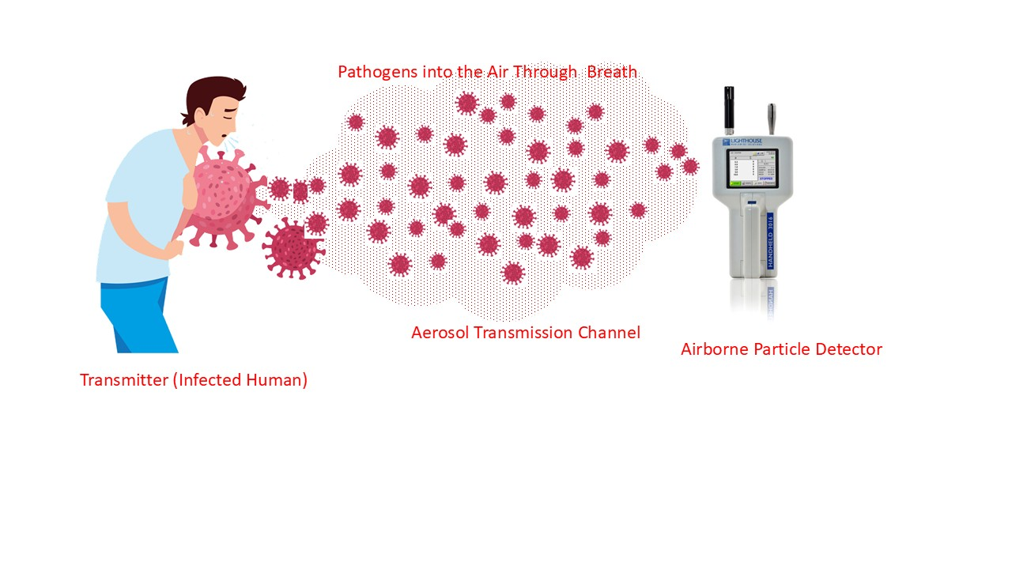

Figure 1. Aerosol transmission Description

**III SYSTEM MODELING**

This section's goal is to examine each system block in Figure2 independently. The transmitter is the first component of the system, followed by the physical channel with additive noise and the detector. The full mathematical modeling of the various system components is presented in the ensuing subsections.

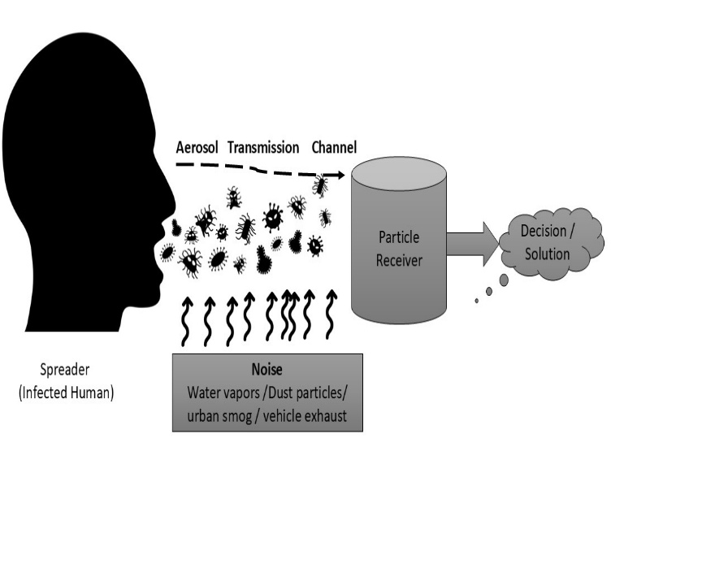

Figure 2 :Block Diagram

**A.** **Spreader**: It is assumed that the infected person's breath spreads microorganisms into the atmosphere. An adult's normal breathing rate is 12–16 breaths per minute [24], meaning that each breath should take no more than 4.98 seconds. Please be aware that chemical signaling transmission is much slower than wireless communication, and it may take several minutes for the signal to reach a receiver a few meters away. Therefore, the transmission procedure guarantees that the experiment's time scale is on the order of minutes. The differences in the emission process caused by exhalation can be averaged out and the process can be roughly described as a continuous and constant emission process because the time within breaths (or exhalation time specifically) is too short in comparison to the experiment's duration, which is of the order of several minutes. Although the emission rate may fluctuate over time, we anticipate that the average rate will remain consistent for the duration of the experiment (a few minutes at most). Finding a deterministic or stochastic model that can explain these variations in the literature is challenging, despite the fact that it is beneficial if the emission rate variations can be included in the system design. The majority of empirical research on this topic is based on gathering breath samples that range in duration from a few minutes (about 30 minutes) to hours and documenting the cumulative effect. It is unclear if the existing technology can assess the fluctuations in the emission rate per second for the brief time frames. As a result, we represent the input signal as a continuous process with a constant average emission rate, or Q g/sec.

Breathing is a common source of impulsive jets, but they cannot be guaranteed to be constant. The duration of an experiment or the application's temporal features are crucial for simulating the input signal. The steady state response is adequate for certain applications, like understanding disease spread or detection in specific settings. Transitory response is necessary for applications requiring fine-grained data for decision-making. This section covers transient analysis for jet sources, breathing, and steady state response, considering both time and space dynamics. The input is represented differently for transient analysis. A single cough or sneeze is regarded as an instantaneous jet source that releases As aerosols into the atmosphere. If a person standing at position [0,0,H] in any space with a height of around H sneezes or coughs at time t = 0, the source is modeled as [18],

Ss = Asδ(x)δ(y)δ(z −H)δ(t).

Where As is Aerosol of Sneezing person.

In a similar manner, the individual constantly releases aerosols with a specific flow rate Ab while breathing. The source is modelled as follows if the individual entered the room or experimental setting at time t = 0 and then stood at the same spot [0,0,H] again:

Sb = Abδ(x)δ(y)δ(z −H)u(t).

Where Ab is Aerosol of breathing person.

The definition of input signal should cover both continuous and jet sources because a person who sneezes is also breathing. Therefore, we define the final input signal as follows, assuming that both of these emissions are independent of one another:

St=SS+Sb

If there are several persons in the room at different places, their independence from one another means that the final input signal is simply the sum of all of their emissions. The size of the aerosol droplets influences the communication performance in addition to the emission rate.

**B. Particle Receiver**: We suggest a detection method that could be used to differentiate between an infected and healthy individual. The receiver serves as an absorbing surface that absorbs the majority of the pathogen-laden droplets after the infected person has discharged a specific quantity of pathogens into the atmosphere and they have crossed the molecular channel. The architecture of particle receiver is shown in Figure 3. The details of three major blocks are presented below.

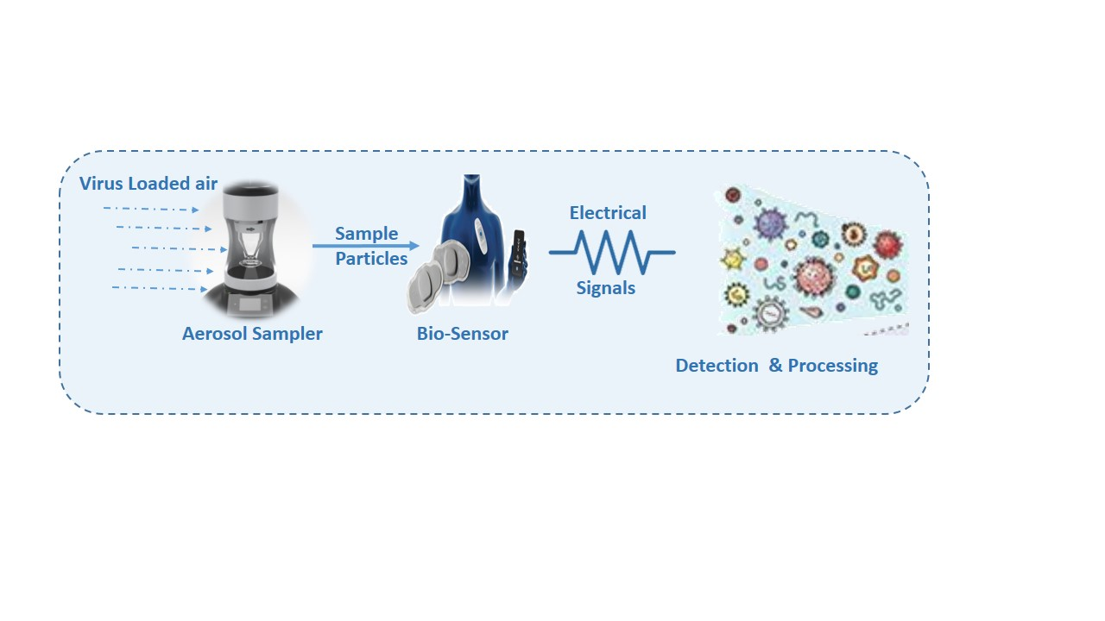

Figure 3: Architecture of Particle Receiver

* **Aerosol Sampler**: A number of methods for gathering suspended air particles have been developed. The front end of our receiver, known as the aerosol tester, regulates the air sampling rate. The tester suggested in this receiver architecture is based on the electrostatic precipitation concept, which is not only commercially available but also enables sampling of particles as small as 2–100 nm, despite the existence of various alternative methodologies. Since the diameter of bacteria and viruses can generally be of the order of nanometers and droplet sizes are of the scale of a few micrometers, the sampler's sensitivity in terms of sampling nano-sized particles is quite considerable. Figure 4 shows the electrostatic air sampler's construction. The ionizer and the charged electrode are the sampler's two primary parts. After being repelled by the outer negatively charged boundary, the ionizer creates a negative charge on the air particles that move on to the next chamber and gather on the positively charged electrode. The efficiency of the sampler's collection is used to measure its performance. Commercial electrostatic aerosol samplers can achieve collection efficiencies of 80 to 90%, as reported in [16]. For the remainder of the work, we use ξ to represent sampler efficiency.

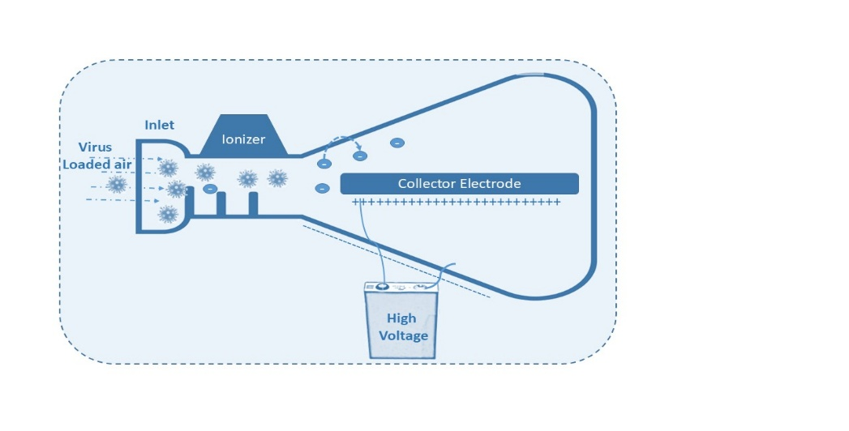

Figure 4: The Electrostatic Air Sampler's Construction

* **Biosensor**: A sophisticated analytical tool called a biosensor converts biological reactions into electrical signals. These instruments are essential for identifying and quantifying the levels of different biological materials. A biosensor may detect parameters of biological significance even in the absence of direct interaction with a biological system. Biosensors function by connecting a transducer to a biological sensing element, such as enzymes, antibodies, or nucleic acids. By transforming the biological connection into an electrical signal, the transducer serves as a detector. The basis for the current advancement of biosensing technologies was established by the first useful biosensors, which were electrochemical sensors made to measure various analytes[17].

As shown in Figure 5, a biosensor is essentially made up of three essential parts. The first is the sensor, which is a biological material that is sensitive, such tissues or microbes. The transducer, the second component, uses techniques like optical or electrochemical detection to identify the interaction between the analyte and the biological element. Lastly, the related electronics that process the signal and show the outcomes make up the third component.

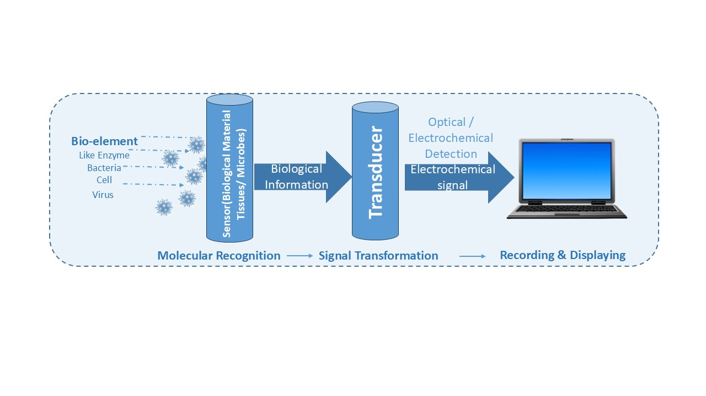

Figure 5 : Biosensor Working

**Aerosol Biosensor Experimental Data Table 1 :**

|  |  |  |  |
| --- | --- | --- | --- |
| Parameter | Sensor type | Tentative value | Units |
| Detection Limit | Electrochemical | 5 | Ppb |
| Sensitivity | Optical | 0.2 | (A.U.)/ppb |
| Response Time | Piezoelectric | 15 | Sec |
| Choosiness | Electrochemical | 98 | % |
| Constancy (7 Days) | Electrochemical | 90 | % |

Several aerosol biosensors are shown in table 1, with an emphasis on stability, sensitivity, response time, and detection capabilities. The primary revelations are: Electrochemical sensors are extremely sensitive for trace-level detection, detecting particles as little as 5 ppb parts per billion. With a high sensitivity of 0.2 A.U./ppb(Arbitrary Units), optical (fluorescence-based) biosensors may produce a powerful signal at even low analyte concentrations. Because piezoelectric sensors (such the Quartz Crystal Microbalance, or QCM) react in 15 seconds, they are useful for monitoring in real time. The 98% selectivity of enzyme-based electrochemical sensors indicates that they can reliably differentiate the target aerosol from other airborne materials. Reliable performance over repeated tests is ensured by optical (SPR-based) sensors, which vary by ±3% over several trials. After seven days, electrochemical sensors maintain 90% of their original signal, indicating long-term usage with little need for calibration. Low interference means that regardless of changes in temperature, humidity, and air composition, the data from all types of sensors stay consistent.

**Comparison of Viral Aerosol Biosensors:**

* + Electrochemical biosensors are excellent for ultra-low detection limits and real-time monitoring.
  + Optical biosensors work well in public areas for quick screening of flu-like viruses.
  + SPR-based biosensors offer the highest selectivity and accuracy, useful in hospitals and quarantine facilities.

**Table 2: Comparison of Viral Aerosol Biosensors:**

|  |  |  |  |
| --- | --- | --- | --- |
| Virus Type | Best Sensor Type | Key Advantage | Limitations |
| COVID-19 (SARS-CoV-2) | Electrochemical (EIS) | High sensitivity, real-time detection | Needs trained operators |
| Influenza A (H1N1) | Optical (Fluorescence) | Fast response, non-invasive | Sensitive to environmental factors |
| SARS-CoV | SPR-based Immunosensor | High selectivity, reliable readings | Expensive setup, slower processing |

**IV Aerosol Transmission Channel**

Both theoretical analysis and the construction of the best receiver/detector depend on an accurate channel model. The dynamics that propel the message from the source to the receiving machine are described by the model. Aerosols are transported to distant devices by the (artificial) wind, which serves as the carrier. The two main processes that cause aerosol motion are advection and diffusion, and this aerosol movement is an example of fluid flow. The wind, which can be characterized by wind velocity, is the cause of advection, also referred to as convection.

Diffusion can be divided into two categories: turbulent diffusion and molecular diffusion. Molecular diffusion is the term used to describe the thermal motions caused by molecules' innate urge to seek equilibrium. On the other hand, turbulent diffusion refers to the mass transfer or diffusion that happens as a result of turbulent eddies. The diffusivity coefficient characterizes the diffusion process, and Fick's law can be used to approximate the flow changes brought on by molecular diffusion.

It should be mentioned that molecular diffusion is insignificant in comparison to turbulent diffusion and is frequently disregarded in the modeling process from the viewpoint of aerosol communication put out in this work, where advection plays a major role. Diffusion-based MC[1], on the other hand, is mostly based on Fick's law and concentrates solely on molecular diffusion. The two channels' models are completely different as a result of these variations in the fluid dynamics. un order to facilitate analysis, it is also assumed that the flow is incompressible due to the small variations un density in the flow field.

This communication is micro-scale since it is caused by the abnormal motions of molecules. Conversely, dispersion models can be used to describe aerosol communication, which is the macro-scale movement of microparticles over longer distances. Furthermore, advection and turbulent diffusion primarily control the movement of bioaerosols in the atmosphere, with molecular diffusion playing a very small role. Advection is caused by the wind, and turbulent diffusion is brought on by eddies. In dispersion models, the molecular diffusivity coefficient can be disregarded because the eddy diffusivity coefficient is significantly higher.

Determining the aerosol concentration during various system stages is the goal of the mathematical model.In order to achieve this, we characterize the system dynamics that arise from the addition of one or more aerosol sources to the system using the law of mass conservation. . Occasionally, inactivation processes like ground absorption or receiver-side collection are used to remove these aerosols from the system. We employ the well-known Navier-Stokes equation, which may be coupled with the continuity equation to formally characterize the system, to examine the behavior of aerosol mobility in both spatial and temporal domains. In order to obtain an expression for aerosol concentration, these partial differential equations are solved under certain initial and boundary conditions, which is generally not an easy procedure[19].

1. **Deterministic Modeling**

The previously mentioned sets of partial differential equations (Navier-Stokes and continuity equations) must be solved while taking boundary and initial conditions into account in order to create deterministic models for the channel. For deterministic modelling, there are two possible outcomes: transient analysis and steady state. Regarding the former, the Gaussian Plume model [19] provides the answer after defining a simplified set of boundary conditions and estimating breathing as a continuous, constant source at a fixed point. The concentration profile in this model assumes a Gaussian form along the centreline at a set point along the downwind direction (the line of sight from source to machine). Furthermore, the standard deviation rises as we move downwind away from the source. Therefore, as we travel away from the source and toward the detector direction, it resembles a collection of Gaussian curves (in the y-z plane) of increasing variance stacked along the x-axis. Regarding the transitory analysis, we examine how a single breath, cough, or sneeze affects concentration. The Gaussian Puff model provides the solution to this situation.

1. **Stochastic Modeling**

Calculating the concentration of particles with accuracy is made more difficult by the inherent randomness of fluid motion. Furthermore, it is quite challenging to arrive at a tractable ideal model because of the non-linear behavior and flow-dependent character of turbulent motion [20]–[22]. In this instance, solving a set of stochastic differential equations is the most difficult method, whereas using a random walk model is the most basic. It is difficult to derive the density function or a near form formula for this random process. In order to replicate the turbulent flow, we thus turn to tracking the fluid elements' movement at each moment in time. Particle dispersion is caused by a random velocity component made up of stochastic variations and drift (mean). An analytical solution with a mean concentration profile is provided by the simplified Gaussian plume model. However, stochastic models are necessary to accurately simulate physical systems involving fluid flow. Lagrangian and Eulerian are two widely used computational models that are based on fluid flow requirements. The Lagrangian method tracks and tags particles to keep an eye on their location, velocity, and other relevant characteristics. Conversely, the Eulerian method takes into account a fixed frame of reference or control volume that is used to track the fluid's characteristics. The Eulerian technique monitors the behavior of its markers as fluid flows across them rather than the characteristics of individual particles. Therefore, for each sample instant, the calculation consists of solving the proper differential equations for the specified locations.

The same two methods are used once more when statistical analysis is involved. A collection of instantaneous differential equations serves as the foundation for the Eulerian approach [20]–[22], from which other equations determining the known statistics (mean and variance of velocity) are derived. In order to arrive at a set of closed equations for these unknowns, models for unknown values based on known statistics are already available. By using conservation equations and the statistical description of fluid variables like velocity, the Lagrangian technique determines the location of particles.

**V. VIRAL AEROSOL TRANSMISSION AND DETECTION**

We examine a case study of identifying a virus from the aerosol of contaminated human breath in this section. We must comprehend the "symbol" analogy to the traditional communication system in order to comprehend the consequences of the channel behavior of the suggested communication system. In this instance, the symbol that conveys the relevant information is defined by the aerosol concentration from a single source over time. We examine an impulse source in the spatiotemporal dimension, much like in communication systems, where the channel behavior is described by the impulse response. To do this, we assume that at time t = 0, an instantaneous transmitter of height H is situated at the origin and emits a significant quantity of aerosols Q into the atmosphere. The aerosol concentration is calculated using the Gaussian puff model and collected at different milliseconds (ms). The x-axis, or downwind direction, is thought to have the largest wind component, whereas the crosswind direction is thought to have the least impact. We saw that the aerosol particles are concentrated around the origin, or source, at particular milliseconds. Other aerosol samples disperse throughout the spatial area with lower peak values as they travel downwind. As a result, the breath transmission takes place across a long-tail dispersive fading channel, which results in latency and interference between the current and previous system symbols. Stated differently, the channel's frequency-selective properties have the potential to cause Inter Symbol Interference (ISI) on many accepted systems.

Depending on environmental conditions, viral aerosols can have life periods of up to 72 hours and range in size from 0.1 to 5 µm. Within five to twenty minutes, detection methods (such as electrochemical, optical, and QCM-based biosensors) can detect viral aerosols with limits as low as one copy/mL. High temperatures (>30°C) decrease viral vitality, whereas humidity (40–60%) increases transmission. The 95–99% selectivity offered by qRT-PCR and biosensors guarantees precise identification of airborne viruses as shown Table 3 .

**Table 3: Viral Aerosol Transmission and Detection – Experimental Data**

|  |  |  |  |  |
| --- | --- | --- | --- | --- |
| Parameter | Tentative value | Units | Dimension Method | Meaning |
| Particle Size (Virus-Laden Droplets) | 0.1-5 | µm | Aerosol Particle Sizing (APS), Scanning Electron Microscopy (SEM) | Evaluates the stability and risk of propagation of airborne viruses. |
| Airborne Survival Time | 3-72 | Hours | Controlled Chamber Studies, Viral Culture Assays | Virus capability be subject of humidity, temperature, and UV exposure. |
| Detection Limit  (Biosensor Sensitivity) | 1-10 | Copies/mL | Electrochemical, Optical | Lower detection limits permit primary contagion detection. |
| Response Time of Biosensors | 5-20 | Minutes | QCM, Amperometry, Fluorescence | Quick detection is critical for real-time monitoring. |
| Selectivity (False Positives/Negatives | 95-99 | % | RT-PCR vs. Biosensors Comparison | Guarantees correct viral detection, avoiding misdiagnoses |
| Stability of Detection Methods | 85-95 | %(over 7 days) | Continuous Signal Monitoring | Long-term consistency for epidemic surveillance. |
| Effect of Humidity on Transmission | Higher at 40–60% | RH(%) | Environmental Chamber Testing | Restrained humidity increases aerosol stability. |
| Impact of Temperature on Virus Viability | Reduces above 30°C | °C | Controlled Temperature Experiments | High temperatures reduce virus survival. |
| Airborne Viral Load in Infected Environments | 10² – 10⁵ | RNA copies/m³ | Air Sampling & qRT-PCR | Indicates risk level in closed spaces. |

We also discover that the concentration of viral aerosol is detectable for a longer period of time after the infected person exits the test room. Aerosol droplets demand specific design consideration because of their extremely slow propagation speeds, which have a lag of seconds, in contrast to electromagnetic signals, which move at the speed of light. Before the system is implemented, a number of issues that could affect the suggested system need be resolved.

**VI NUMERICAL RESULTS**

This part examines the spatial temporal viral concentration and the missed detection probability in order to undertake a numerical analysis of the suggested system performance. As assumed in Figure 6, the receiver is a sphere of radius rd positioned in-line with the source along a downwind direction in the y−z plane at a distance of dx, with its center at us = [dx,0,H]. This assumption is maintained throughout the subsequent numerical findings. We further suppose that the receiver is situated in an environment that is completely sterilized. Unless otherwise noted, we use the settings given in Table I in the numerical results that follow.

Table 3

|  |  |
| --- | --- |
| Parameters | Values |
| ū | 140 cm/sec |
| H | 180 cm |
| K | 0.242 cm2/sec |
| rd | 2 cm |

We examine the impact of airflow velocity and distance on the received virus concentration at the receiver side in the first numerical scenario. We analyze the collected viral concentration performance as a ratio of the released virus R versus the distance between the infected individual and receiver for various u ranges, assuming a sampling time of 3 seconds. The air flow velocities are selected to simulate coughing, artificial air flow, and exhaled nasal breaths with velocities below 140 cm/s . First, we note that airflow velocity is the primary determinant of the spatial viral signature. Because of the mass conservation equation, raising u can result in a decrease in concentration, but it can also increase the detection area [53]. Therefore, using air flow helps increase the detection's spatial coverage, but it may also lower the concentration below a level that can be detected.

**V CONCLUSION**

The study established a new area of study in MC: the transmission, dissemination, and detection of viral aerosols. Understanding the dynamics of virus dissemination through mathematical modeling of the aerosol channel can be useful in detecting the virus. An important enabler for the viral detection system is the application of artificial airflow, which overcomes the slowness of diffusion-based dissemination and permits the identification of viruses. The simulation results demonstrate that a number of factors, including distance, air velocity, virus flow rate, and receiver binding efficiency, influence missed detection. The steady state analysis of virus transmission and detection due to breathing was used to study the suggested mathematical problem. It was expanded to include transitory analysis and the system's reaction to sneezes and coughs. A number of receiver design elements, including synchronization and memory channel behavior, depend on the transient analysis. The work can be expanded in further studies by introducing complicated wind fields and loosening the assumptions, which will provide distinct turbulence behavior. Optimizing the size and/or position of the receivers is also essential, as is researching various sources, interference, and turbulence models. Last but not least, this study can potentially be expanded to include anticipating pandemics and taking preventative action.

REFERENCES

[1] T. Nakano, M. J. Moore, F. Wei, A. V. Vasilakos, and J. Shuai, “Molecular communication and networking: Opportunities and challenges,” IEEE Trans. Nanobiosci., vol. 11, no. 2, pp. 135–148, Jun. 2012.

[2] T. Suda et al., “Exploratory research on molecular communication between nanotechnology,” in Prof. ACM Conf. Genetic Evol. Comput. (GECCO), 2005, p. 29.

[3] D. Malak and O. Akan, “Communication theoretical understanding of intra-body nervous nanonetworks,” IEEE Commun. Mag., vol. 52, no. 4, pp. 129–135, Apr. 2014.

[4] U. A. K. Chude-Okonkwo, R. Malekian, B. T. Maharaj, and A. V. Vasilakos, “Molecular communication and nanonetwork for targeted drug delivery: A survey,” IEEE Commun. Surveys Tuts., vol. 19, no. 4, pp. 3046–3096, 4th Quart., 2017, doi: 10.1109/COMST.2017.2705740.

[5] N. Farsad, H. B. Yilmaz, A. Eckford, C.-B. Chae, and W. Guo, “A comprehensive survey of recent advancements in molecular communication,” IEEE Commun. Surveys Tuts., vol. 18, no. 3, pp. 1887–1919, 3rd Quart., 2016.

[6] A. Einolghozati, M. Sardari, and F. Fekri, “Design and analysis of wireless communication systems using diffusion-based molecular communication among bacteria,” IEEE Trans. Wireless Commun., vol. 12, no. 12, pp. 6096–6105, Dec. 2013.

[7] R. Tellier, “Review of aerosol transmission of influenza a virus,” Emerg. Infectious Diseases, vol. 12, no. 11, pp. 1657–1662, 2006.

[8] B. J. Cowling et al., “Aerosol transmission is an important mode of influenza a virus spread,” Nature Commun., vol. 4, no. 1, Oct. 2013, Art. no. 1935.

[9] I. T. S. Yu et al., “Evidence of airborne transmission of the severe acute respiratory syndrome virus,” New England J. Med., vol. 350, no. 17, pp. 1731–1739, Apr. 2004.

[10] N. Johnson, R. Phillpotts, and A. R. Fooks, “Airborne transmission of lyssaviruses,” J. Med. Microbiology, vol. 55, no. 6, pp. 785–790, Jun. 2006.

[11] W. G. Winkler, “Airborne rabies transmission in a laboratory worker,” J. Amer. Med. Assoc., vol. 226, no. 10, pp. 1219–1221, Dec. 1973.

[12] I. Abubakar et al., “Global perspectives for prevention of infectious diseases associated with mass gatherings,” Lancet Infectious Diseases, vol. 12, no. 1, pp. 66–74, Jan. 2012.

[13] R. J. Hatchett, C. E. Mecher, and M. Lipsitch, “Public health interventions and epidemic intensity during the 1918 influenza pandemic,” Proc. Nat. Acad. Sci. USA, vol. 104, no. 18, pp. 7582–7587, May 2007.

[14] A. V. Gundlapalli et al., “Influenza, winter olympiad, 2002,” Emerg. Infectious Diseases, vol. 12, no. 1, p. 144, 2006.

[15] E. S. Jentes et al., “Health risks and travel preparation among foreign visitors and expatriates during the 2008 Beijing olympic and Paralympic games,” Amer. J. Tropical Med. Hygiene, vol. 82, no. 3, pp. 466–472, Mar. 2010

[16] D. Rimberg and D. Keafer, “Evaluation of a commercial electrostatic aerosol sampler,” Atmos. Environ., vol. 5, no. 1, pp. 65–66, Jan. 1971.

[17] M. Kuscu and O. B. Akan, “On the physical design of molecular communication receiver based on nanoscale biosensors,” IEEE Sensors J., vol. 16, no. 8, pp. 2228–2243, Apr. 2016.

[18] D. A. Edwards et al., “Inhaling to mitigate exhaled bioaerosols,” Proc. Nat. Acad. Sci. USA, vol. 101, no. 50, pp. 17383–17388, Dec. 2004. [Online]. Available: http://www.pnas. org/content/101/50/17383.abstract

[19] M.Khalid, O. Amin, S. Ahmed, and M.-S. Alouini, “System modeling of virus transmission and detection in molecular communication channels,” in IEEE Intern. Conf. Commun. (ICC18). Kansas, USA: IEEE, 2018, pp. 1–6.

[20] S. B. Pope, Turbulent Flows. Cambridge University Press, 2000.

[21] S. P. Arya, Air pollution meteorology and dispersion. Oxford University Press New York, 1999, vol. 310.

[22] G. I. Taylor, “Diffusion by continuous movements,” Proceedings of the london mathematical society, vol. 2, no. 1, pp. 196–212, 1922.